QC Tool Deletion Requirement
Introduction

QC Tool Deletion is to let QC tool administrator to remove one or more series in a study for a patient. Deletion is categorized as soft deletion and hard deletion. By definition, soft delete is to mark one or more series as a to-be-deleted. Hard delete is that NBIA application removes marked records from database; all related DICOM image files will be removed as well in hard delete.

Image Status

In current QC tool function, there are three statuses to each images, “not yet review”, “not visible”, and “visible”. In order to implement QC tool deletion, there are two statuses need to be created, “to be deleted”, “deleted”. As we mentioned before, there two level deletions will be in QC tool. When soft deletion occurs, all images in one or more series will be marked as to-be-deleted. This status can be interchanged back to any three statuses, “not yet review”, “not visible”, and “visible”. When hard deletion occurs, all images in one or more series will be marked as “deleted” and this status is final status and cannot be changed anymore. A CRON job will kick in at some time period to remove all records from database, and all image from file system.

Deletion Processes

As we all know, QC tool deletion might interfere with Data Insertion (CTP). In order not to mess up with QC tool deletion, data insertion cannot change any status which QC tool marked. For instance, after QC tool marked one or more series to “to-be-deleted”, Data insertion happens to update these series, in this case, Data Insertion will not update status “to-be-deleted” to any status that CTP specified. Therefore, CTP needs to fetch the previous status and ignore CTP specified status when update occurs. This rule is not suitable for new records insertion. In another case, when one or more series marked as “deleted”, CTP needs to quarantine all image files for these series because these images are the candidate to be deleted.

Database Adapter (CTP)
Adding a function to check records status. If previous records exist and status in not “deleted”, fetch the current status, update rest of data. If previous records exist and status in “deleted”, quarantine the updating images.
Use cases
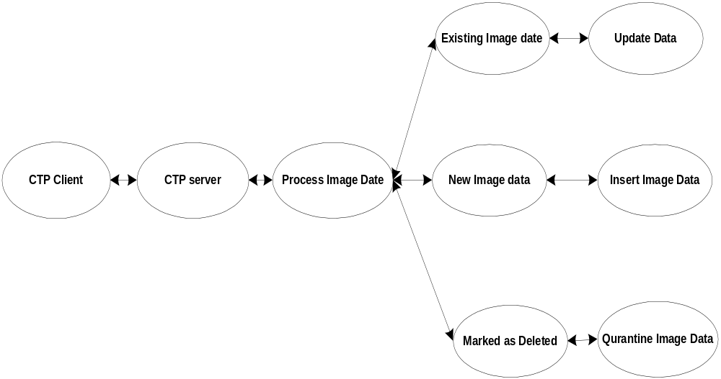

QC Tool deletion happens at midnight every day. A deletion module will be implemented to remove all records from database and all files from file system. A CRON job will execute this module. In the deletion module, it needs to do some analysis on data which will be removed. Since deletion happens on series level, this module needs to know how many series in this study, if there is only one series in this study, this study also need to be removed. If there is more series exist, only this series will be removed. The same theory applies to Studies and Patients.

QC Tool deletion
Adding a function to delete records which are marked as “deleted”.
Use cases
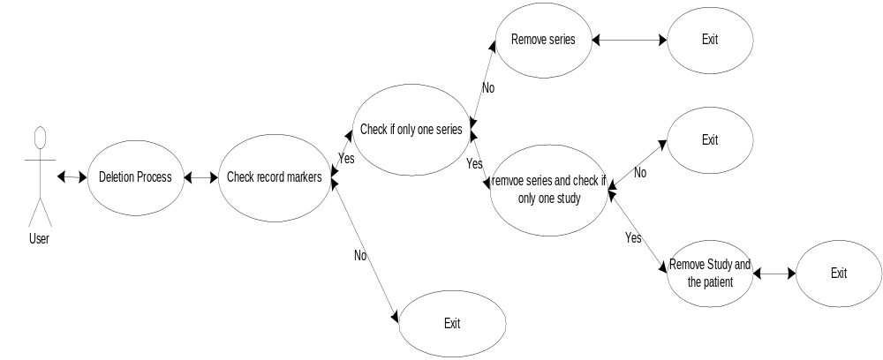

Online Deletion Tool
This is a special requirement for data submitters. This tool will provide a function to let data submitter can remove data records and files that submitted previously immediately. The reason for the tool is data submitters might send some test data to the server first to make sure UIDs are good. If there are some things are messed up, so they remove it quickly and resubmit them. Disadvantages for this approach is if data submitters remove a large mount of data, the consequence is this could affect NBIA performance, even break application.
The deletion process is exactly same as QC hard deletion exception. This process will be invoked by data submitters instead of CRON job.
Audit Trail
In the deletion process, database needs to record some information like who did it, when it happened, why deletion occurred etc. Therefore, audit trail process is needed in hard deletion. After remove all images in a series, the series UID will be records in database with other information, such as person who delete it, when this series is deleted, for what reasons this series is deleted. If study or patient is needed to be deleted, the same information will be recorded for this study or patient.

